Rae Yoshioka

Nakia Patton

Gabby Strevay

Project Progress Report Week #1

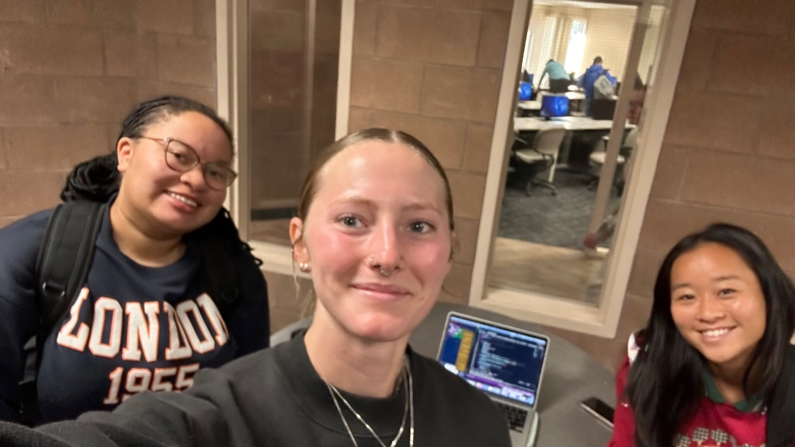

Currently: We have the background and character movement (need to make sure character can’t “fall” off screen aka go beyond the boundaries). We have the character starting position. Able to move the character in a certain direction and have it stop before taking the new updated position of the character.

Next week’s plan: Creating the pixel visuals for the chests to hide the colors in and the drop off logic in the game so that you can collect and drop off the 3 colors to win the game. Also making sure the character cannot go beyond the boundaries of the game. Brainstorming together how that could look in implementation.